 | EUROPEAN COMMISSION  DIRECTORATE-GENERAL  INFORMATICS  Information systems Directorate

European Commission
e-TrustEx Use Case Specification: Submit Document Template

Date: | 15/10/2014
Version: | 2.005
Authors: | Olivier Derveau, Anamaria Batrinu
Revised by: | Technical Review:  Quality Review:
Approved by:
Public:
Reference Number:

TABLE OF CONTENTS
1. Use-Case Description 3
2. References 3
3. Points of Extensions 3
3.1. Points of extension mapping 3
3.2. Document Type Code 4
3.3. Party Roles 4
3.4. Document Identifier 4
3.5. Document Issue Date 4
3.6. Synchronous XSD Validation 4
3.7. Synchronous Schematron Validation 4
3.8. Synchronous Specific Validation 4
3.8.1. Synchronous SLA Validation 4
3.8.2. Other specific validation 5
3.9. Synchronous Business Specific Processing 5
3.10. Asynchronous XSD Validation 5
3.11. Asynchronous Business Rules Validation 5
3.11.1. Asynchronous Schematron Validation 5
3.11.2. Asynchronous Parent-Child Relationship Validation 5
3.11.3. Reprocessing Timeframe for Parent Document 5
3.11.4. Asynchronous Specific Validation 5
3.12. Asynchronous Business Specific Processing 5
3.12.1. Human Readable Generation 5
3.12.2. SLA Policy Validation 5
3.12.3. Other specific processing 6
3.13. Availability Notification 6
3.14. State Machine 6
3.14.1. Transition to state Approved 6
3.14.2. Transition to state Rejected 6
3.15. Dispatching 7
4. Additional Information 7

Document History

Version | Date | Comment | Modified Pages
2.001 | 16/10/2014 | Creation | All
2.002 | 10/11/2014 | Implement comments for Philipe Desmet | §1, add §3.4 and §3.9
2.003 | 06/03/2015 | BATRIAN: Reviewed and finalized template
2.004 | 12/03/2015 | BATRIAN:  - added synchronous business specific processing  - updated the link of the application response use case  - updated link of the code list  - corrected duplicate id for extension points  - cleaned template properties
2.005 | 17/03/2015 | BATRIAN:  - updated points of extension mapping  - added availability notification section

Use-Case Description
This Use Case describes the service that enables parties to send [DocumentType] document via electronic means using the e-TrustEx platform. It extends the generic use case UC1_002 Process Asynchronous Message to [DocumentType] document.

References
Document Title | Document Reference
UC1_002 Process Asynchronous Message | https://webgate.ec.europa.eu/CITnet/svn/ETRUSTEX/trunk/001 e-TrustEx/002 Requirements/Use Case Model/New Use Cases/UC1_002 Process Asynchronous Message.doc
Use Case eTrustex – Submit Application Response | https://webgate.ec.europa.eu/CITnet/svn/ETRUSTEX/trunk/001 e-TrustEx/002 Requirements/Use Case Model/New Use Cases/UC1_003 Submit Application Response Use Case Specification_2.0.doc
[DocumentType] XSD document
[DocumentType]Schematron rules document
Code List Document | https://webgate.ec.europa.eu/CITnet/svn/ETRUSTEX/trunk/001 e-TrustEx/003 Architecture/001 Data Model/000 Code Tables/EC_CodeList_e-TrustEx.xls
Human Readable Template | To be defined.

Points of Extensions

Points of extension mapping
Point of extension (in this document) | Extended point (in Asynchronous Use Case)
Document Type Code | Point of extension 2  Point of extension 4  Point of extension 9
Party Roles | Point of extension 1
Document Identifier | Point of extension 3
Document Issue Date | Point of extension 8
Synchronous XSD Validation | Point of extension 5
Synchronous Schematron Validation | Point of extension 6
Synchronous Specific Validation | Point of extension 7
Synchronous Business Specific Processing | Point of extension 17
Asynchronous XSD Validation | Point of extension 10
Asynchronous Schematron Validation | Point of extension 11
Asynchronous Specific Validation
Asynchronous Parent-Child Relationship Validation | Point of extension 12
Reprocessing Timeframe | Point of extension 16
Asynchronous Specific ValidationAsynchronous Specific Validation | Point of extension 18
Data Extraction | Point of extension 13
Asynchronous Business Specific Processing | Point of extension 14
Availability Notification | Point of extension 19
Dispatching | Point of extension 15

Document Type Code
The document type code for [DocumentType] is [DocumentTypeCode] and it is defined in Code List Document, under the sheet DocumentTypeCode.

Party Roles
The [DocumentType] document must be sent by a Party having [DocumentSenderRole] Role and received by a Party having [DocumentReceiverRole] Role.

Document Identifier
The document identifier can be found via the following Xpath expression:
To be completed

Document Issue Date
The document issue date can be found via the following Xpath expression:
To be completed

Synchronous XSD Validation
The document must be valid according to the XSD document[DocumentType].

Synchronous Schematron Validation
The document must be valid according to the following set of rules implemented in the Schematron document[DocumentType]:
To be completed

Synchronous Specific Validation

Synchronous SLA Validation
The document must be valid according to the following SLA policies:
To be completed

Other specific validation
The following rules must be applied during the synchronous validation:
To be completed

Synchronous Business Specific Processing
System performs the following synchronous business processing:
To be completed

Asynchronous XSD Validation
The document must be valid according to XSD document[DocumentType].

Asynchronous Business Rules Validation

Asynchronous Schematron Validation
The document must be valid according to the following set of rules implemented in the Schematron document[DocumentType]:
To be completed

Asynchronous Parent-Child Relationship Validation
The parent document, if it exists, must be valid according to the following specific rules:
To be completed

Reprocessing Timeframe for Parent Document
The reprocessing of the message is done during the following timeframe:
To be completed

Asynchronous Specific Validation
The document must be valid according to the following specific rules:
To be completed

Asynchronous Business Specific Processing

Human Readable Generation
The System retrieves the Human Readable Template specific to this document and applies it to the message, obtaining the Human Readable file which is saved as a binary by the System.

SLA Policy Validation
The message must be valid according to the following SLA policy configurations:
To be completed

Other specific processing
System performs the following specific processing:
To be completed

Availability Notification
The available notification can be found via the following Xpath expression:
To be completed

State Machine
The following state machine shows the usual (generic) states that are Submitted, Received and Error. Beside these states some specific states are displayed in blue: Approved and Rejected. These specific states can be subject to change in the specific use case implementing this template.

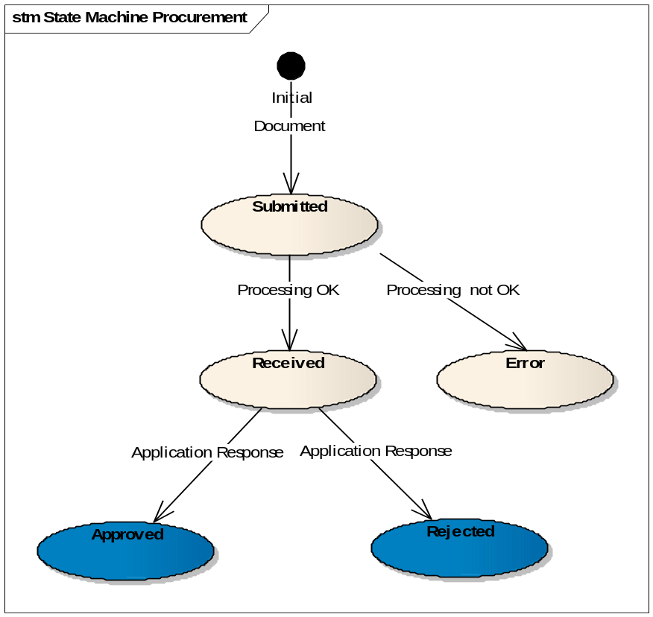

Transition to state Approved
At this point, the Use Case Submit Application Response is included.
When an application response referencing an existing [DocumentType] document in state received arrives in the system with a response code [DocumentTypeCode]:1 the state of the [DocumentType] document becomes Approved.

Transition to state Rejected
At this point, the Use Case Submit Application Response is included.
When an application response referencing an existing [DocumentType] document in state received arrives in the system with a response code [DocumentTypeCode]:2 the state of the [DocumentType] document becomes Rejected.

Dispatching
The following routing rules are used for dispatching the message:
To be completed

Additional Information
To be completed

